Case Study: SavePlate – Smart Food Waste Reduction App
We as Malaysians love food but alongside of this is food waste. SavePlate is an app to be developed either as a web based or mobile. This app is to help reduce household food waste through intelligent inventory management, expiry alerts, donation facilitation, and responsible meal planning — while protecting user data and account privacy (refer to Fig. 1)

Reference
Yeong A. (2024) How Malaysians are battling food waste with surplus food
https://www.fairplanet.org/editors-pick/how-malaysians-are-battling-food-waste-with-surplus-food/
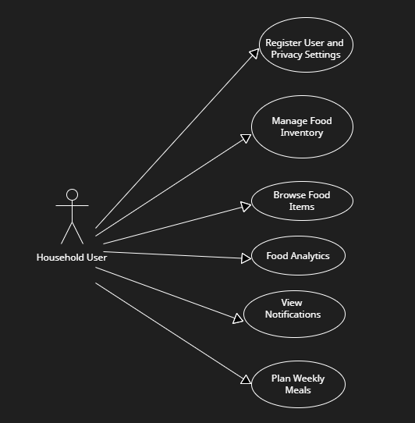
Lower Foyer

Fig. 1: SavePlate Use Case Diagram
2.0 HIGH LEVEL USE CASES

Use Case 1: Register Uses and Privacy Settings

Household users register on the platform and configure privacy/security preferences such as enabling 2FA and setting food listing visibility. These settings can be updated anytime from the account dashboard.

Use Case 2: Manage Food Inventory
- Users log food items stored in their household (e.g., fridge, pantry, freezer) including expiry date, quantity, and category. Items can be edited, marked as used, or moved to donation or to plan weekly meals.
- Users can convert inventory items to donation listings or directly post listings with details like location and expiry.

Use Case 3: Browse Food Items
- Users browse available food listings by location or type.
- Listings display item details and pickup arrangements.
- Users can request/claim donations and receive confirmation notifications.

Use Case 4: Food Analytics
- System provides visual reports on food saved and donations made.
- Progress indicators encourage ongoing engagement.

Use Case 5: View Notifications

- Notifications are sent for upcoming expiry dates, claimed or posted items, meal planning reminders, and privacy/account alerts.

Use Case 6: Plan Weekly Meals

- Users plan meals based on their available food inventory.
- The system may offer suggestions based on expiry dates and available ingredients.

3.0 EXPANDED USE CASES

Use Case 1 | Register Uses and Privacy Settings
Goal in Context | This use case describes how a new user registers for the SavePlate platform and manages privacy and security settings.
Primary Actor | Household Users
Pre-Condition | The user is not registered in the SavePlate system.
Trigger | Registration of a new household user
Typical Course of Events
Actor Action |  | System Response
- User navigates to the registration page. |  | - The registration form is displayed.
- User inputs required registration details: Full name, Email address, Password and Household size (optional) |  | - The system saves the record into the database after validating all inputs.
- User configures privacy and security settings to enable 2FA. |  | - The system sends an automated email to the household user's registered email address, containing: - A welcome message - A confirmation link with the 6 digit verification code
- Upon clicking the link,- the user enters the verification code and sets a new password |  | - System activate the account
Alternative Course of Events
Line 3a: If the username/email had been registered by other user, the system will prompt a message to remind the users.
Line 6: If the entered verification code is invalid or expired, the system prompts the user to request a new code.

Use Case 2 | Manage Food Inventory
Goal in Context | This use case describes how household users can record food items in their personal inventory and manage those items, including marking items for donation as they near expiry.
Primary Actor | Household Users
Pre-Condition | User must be authenticated and logged in to the SavePlate platform.
Trigger | User must be authenticated and logged in to the SavePlate platform
Typical Course of Events
Actor Action |  | System Response
- User navigates to the “Food Inventory” section. |  | - System displays the food inventory dashboard.
- User clicks “Add Food Item” and enters: Item name, Quantity, Expiry date, Category (e.g., canned, frozen), Storage location (optional), and remarks/notes. |  | - System validates input and saves item to inventory.
- User views or edits inventory list. |  | - System displays updated inventory and allows item management (edit/delete).
- User selects item nearing expiry and clicks “Convert to Donation.” |  | - System prompts for confirmation and converts item to donation list.
- User views donation listings. |  | - System displays items marked for donation, which can be modified or removed.  System prompts for additional details (pickup location, availability), then creates a food donation.
Alternative Course of Events
1a. If user submits incomplete form, system displays an error message: “Please complete all required fields “

Use Case 3 | Browse Food Items
Goal in Context | This use case allows household users to view available food items listed in their inventory or shared by others for potential donation or meal planning.
Primary Actor | Household Users
Pre-condition | User must be logged into the system.
Trigger | User chooses to browse available food items from their inventory or donation listings.
Typical Course of Events
Actor Action |  | System Response
- User navigates to the “Browse Food Items” section. |  | - System displays filtering option: Inventory only, Donation listings, Categories, Expiry date, Storage type
- User applies filters or views full list. |  | - System displays the full item details: item name, quantity, expiry date, pickup location, and contact method.
- User clicks on an item for more info. |  | - System shows full item details (e.g., category, storage location, notes).
- User may choose one of the following actions:  • Mark as used  • Plan for meal  • Flag for donation |  | - System updates item status
Alternative Course of Events
4a. If no matching items found with selected filters, System displays “No items found. Please adjust your filters”

7a: if an item is marked for donation, then the system prompts for additional details (pickup location, availability), to create a food donation.

Use Case 4 | Food Analytics
Goal in Context | This use case describes how the system tracks the user’s food-saving activities and generates visual reports to reflect impact, promoting continuous engagement.
Primary Actor | Household Users
Pre-condition | User must have logged food items, marked items as used, or made donations in the system.
Trigger | User selects the "Track My Impact" or "Reports" option from the dashboard.
Typical Course of Events
Actor Action |  | System Response
- User navigates to “Track and Report” from the dashboard. |  | - System retrieves logged activities (e.g., used items, donated items) from inventory and donation records.
- User views summary dashboard |  | - System displays charts and progress indicators showing: Total food saved from waste, Number of donations made
- User clicks on specific data points or date ranges. |  | - . System updates the report view based on filters (e.g., monthly, weekly, by category).
Alternative Course of Events
3a If no food-saving data is found., system shows a message encouraging the user to begin logging and donating to view progress.

Use Case 5 | View Notifications
Goal in Context | This use case describes how the system delivers timely alerts and notifications to keep the user informed about important events, expiring items, and account-related updates.
Primary Actor | Household Users
Pre-Condition | User is logged into the system and has an active inventory, donation listings, or account settings enabled for notifications.
Trigger | System generates a notification based on an event (e.g., approaching expiry date, claimed donation) or user accesses the “Notifications” section from the dashboard.
Typical Course of Events
Actor Action |  | System Response
- User opens the “Notifications” section from the dashboard or clicks on the notification icon. |  | - System displays a list of recent alerts (sorted by most recent) with details and timestamps.  - Inventory Alerts - Items nearing expiry move-to-donation reminders.  - Donation Updates - Confirmation of posted donations, notifications when a listing is claimed, and pickup arrangements.  - Meal Planning Reminders – Alerts for planned meals
- User clicks a notification |  | - System opens the related screen (e.g., inventory item detail, donation request status)
- User marks notifications as read. |  | - System updates notification status and removes unread.
Alternative Course of Events
1a. If user has no new notifications system shows “No new notifications”

Use Case 6 | Plan Weekly Meals
Goal in Context | This use case describes how users plan weekly meals using their current food inventory, helping them reduce waste and optimize ingredient usage before expiry.
Primary Actor | Household Users
Pre-condition | User is logged into the system and has an updated food inventory.
Trigger | User selects the “Plan Meals” option from the dashboard or receives a suggestion/alert from the system about expiring ingredients.
Typical Course of Events
Actor Action |  | System Response
- User selects “Plan Weekly Meals |  | - System displays a calendar view for the week and the user’s current inventory list.
- User chooses days and meal slots (breakfast, lunch, dinner, snacks) to plan. |  | - System allows the user to add meals manually or browse suggested recipes based on available ingredients (focusing on items marked for planned meals).
- User selects a suggested recipe or creates a custom meal plan |  | - System updates the meal plan and links required ingredients to inventory items.
- User confirms the plan for the week |  | - System saves the plan, updates the “reserved” quantities in inventory, and schedules reminders for each meal.
Alternative Course of Events
4a. If no recipes match available ingredients, system displays generic recipes.

